2022 Spring Semester Final Paper C, Exam Test, Closed
Web technique development

Course Teacher: Xiao bao Class: CS182

Directions for answering the paper:
- The paper consists of 3 pages with 1 section of questions. Full score is 100 points;
- Tools or materials permitted:

Student ID: Class:
Name:
Section | One | Total Score | Evaluator
Score

Section One: Problem solving (This section is composed of 1 questions, 100 points each, 100 points in total)
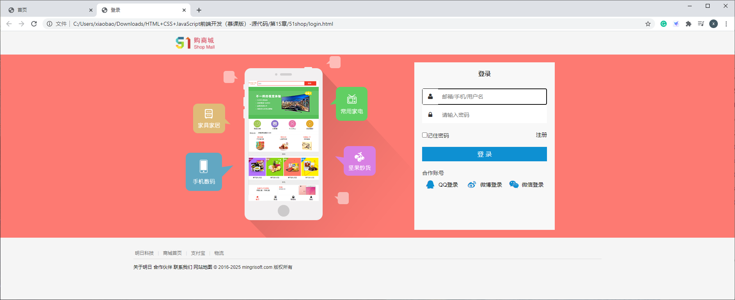
1.Using HTML,CSS and JavaScript, Design two web pages as following.

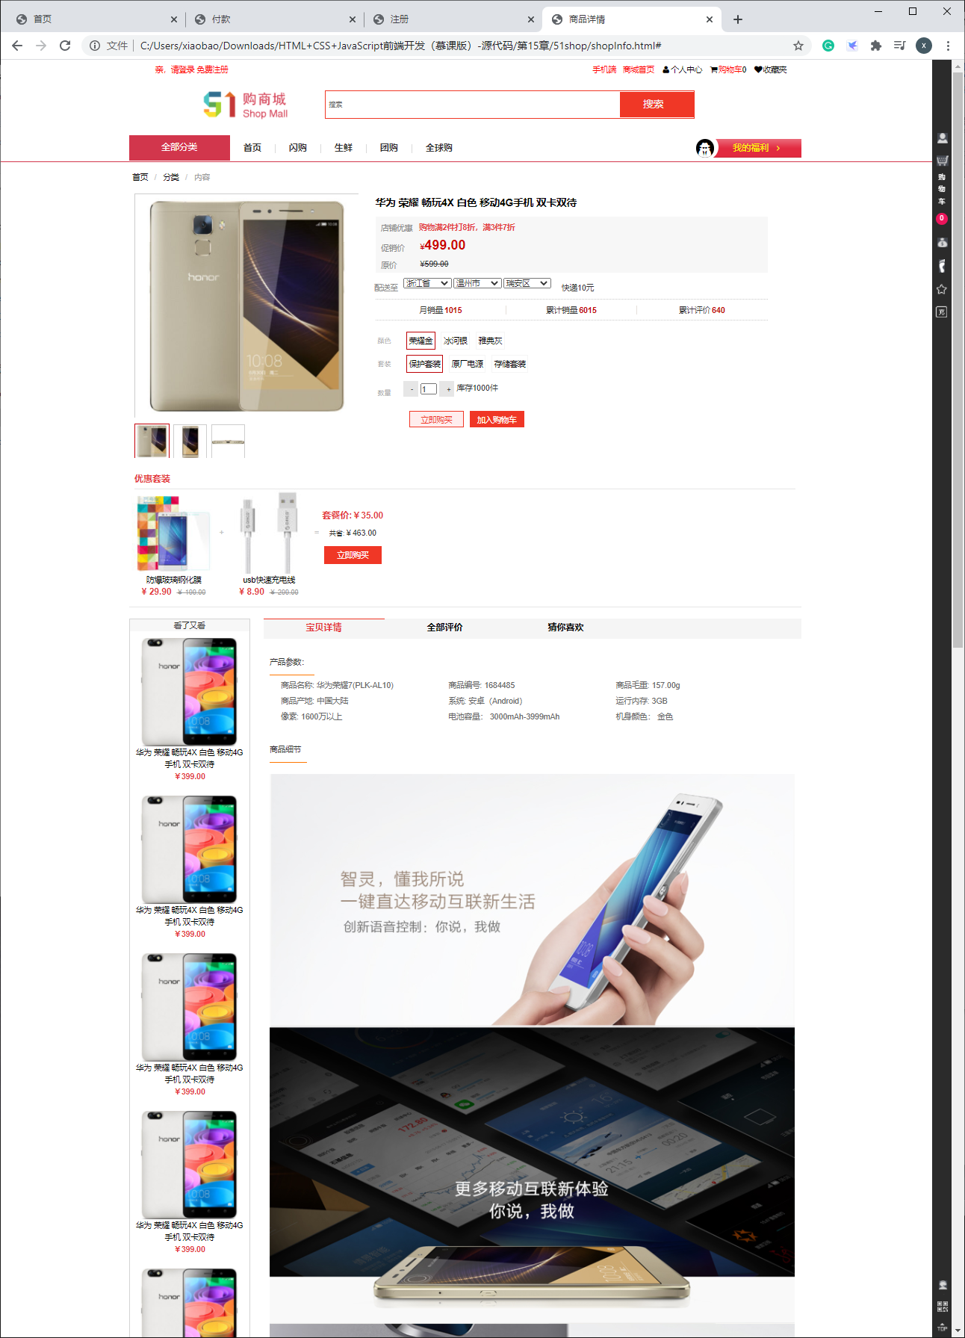

2. Requirements
(1)Create a folder named by student id to store your files. Create three sub directories to save javascript files, css files and images.
(2)copy all images provided to your folders.
(3) The materials to be submitted after the work is completed is the folder as below.
(4)The design must be submitted before May 15, 2022

